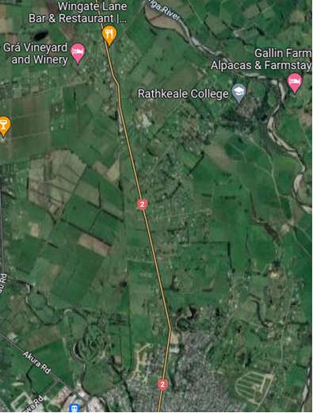
Figure 1: Aerial View of Location of Intersection.
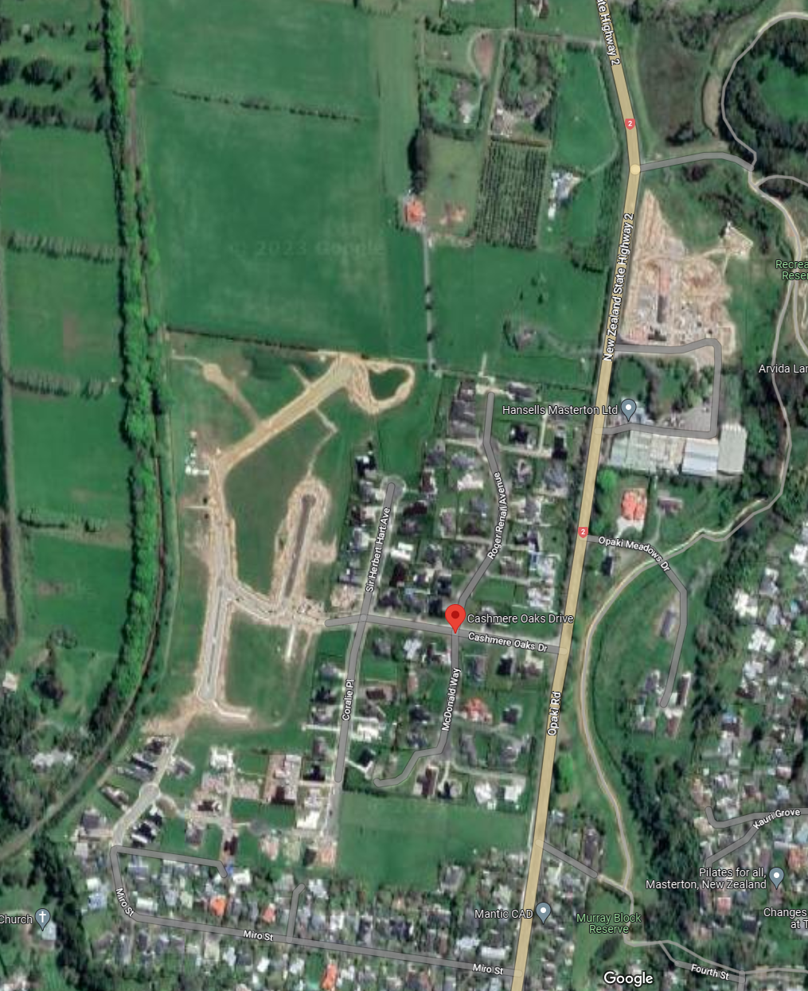
150 m distance between intersection and sign
Figure 5
Figure 3
50 km/h sign
Figure 4

Site
Figure 2: Location of Intersection.
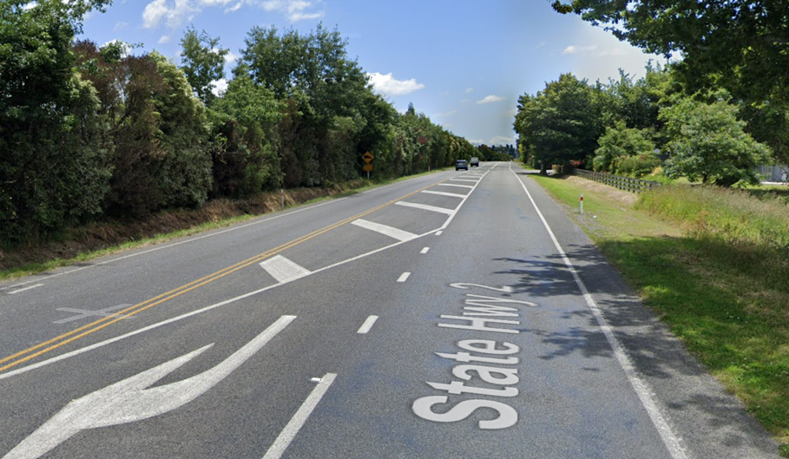
Figure 3: View from Cashmere Oaks Dr looking north away from Masterton showing the rural appearance of SH2 (from page 28 of Mr Glenn Connelly's evidence).
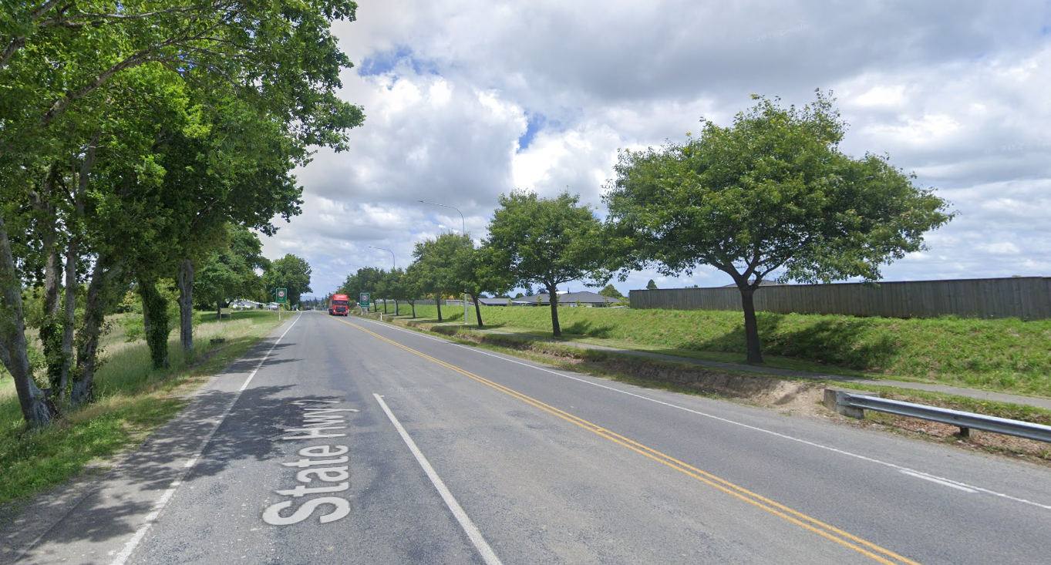
Figure 4: View from Cashmere Oaks Dr looking south toward Masterton showing the absence of urban infrastructure and development (from page 28 of Mr Glenn Connelly's evidence).
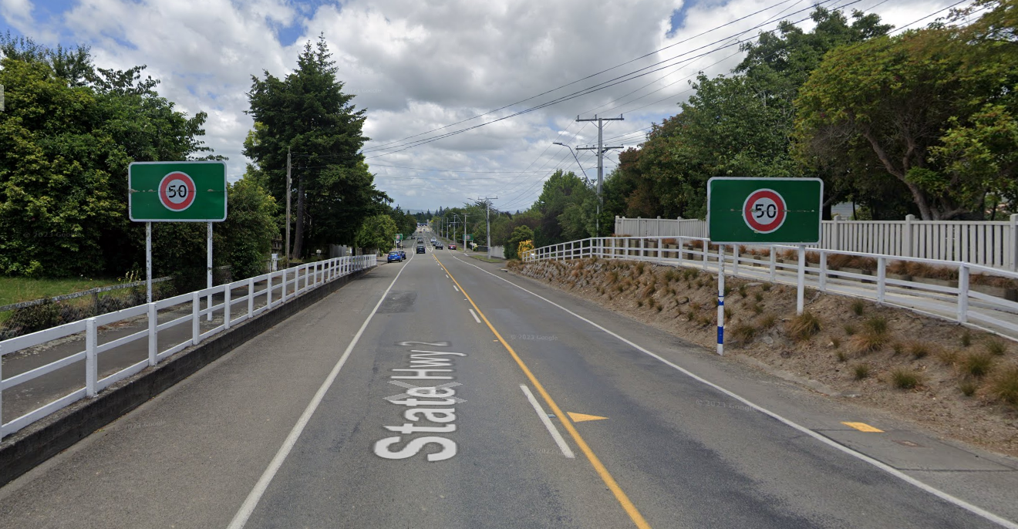
Figure 5: Speed Limit Signs South of Fourth St (from page 29 of Mr Glenn Connelly's evidence).

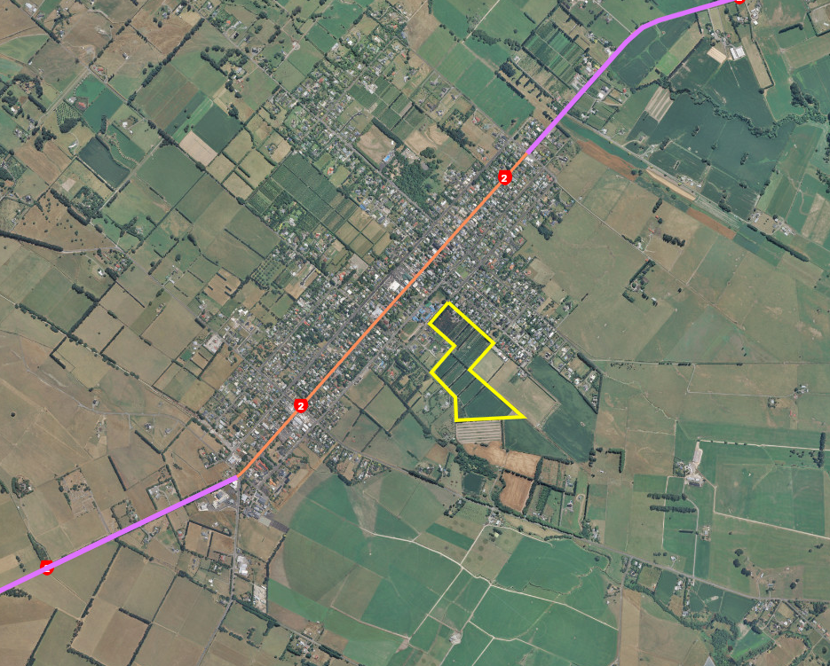
Figure 6: Orchards Plan Change area in Greytown

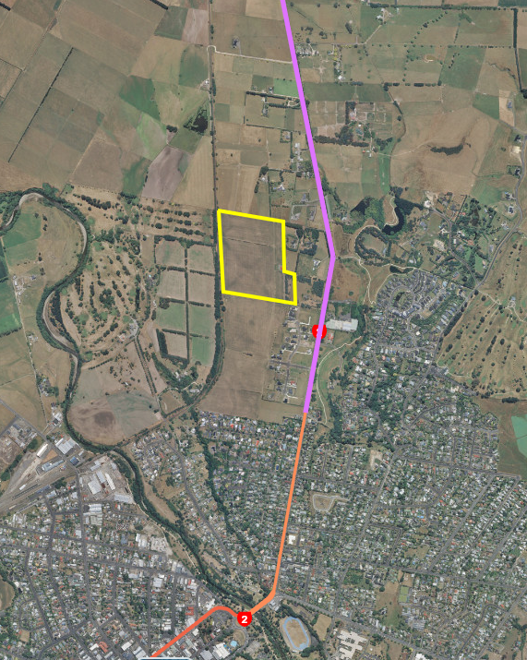
Figure 7: Welhom Plan Change Area

